NOTICE OF PRIVACY PRACTICES ACKNOWLEDGEMENT AND CONSENT

NAME DATE DATE OF BIRTH
I understand that, under the Health Insurance Portability & Accountability Act of 1996 ("HIPAA"), I have certain rights to privacy regarding my protected health information. I understand that this information can and will be used to:
- Conduct, plan and direct my treatment and follow-up among the multiple healthcare providers who may be involved in that treatment directly and indirectly.
- Obtain payment from third-party payers.
- Conduct normal healthcare operations such as quality assessments and physician certifications.
I have had the opportunity to understand your Notice ofPrivacy Practices containing a more complete description of the uses and disclosures of my health information. I understand that this organization has the right to change its Notice of Privacy Practices from time to time and that I may contact this organization at any time at the address below to obtain a current copy of the Notice ofPrivacy Practices.
I understand that I may request in writing that you restrict how my private information is used or disclosed to carry out treatment, payment or healthcare operations. I also understand you are not required to agree to my requested restrictions, but if you do agree then you arc bound to abide by such restrictions.

SIGNATURE RELATIONSHIP TO PATIENT
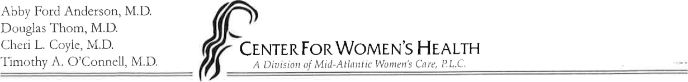
I attempted to obtain the patient's signature in acknowledgement on this Notice of Privacy Practices Acknowledgement, but was unable to do so as documented below:

DATE INITIALS REASON
Patients 18 and over must complete the following:
I hereby authorize Center for Women 's Health (MAWC) to use or disclose the following:
HealthCare (Z Other
My protected health information may be disclosed to:
(List all Names)
This protected health information is being used or disclosed to provide healthcare.
This authorization shall be in force and effective until: (check one of the following) No expiration C] Other
I understand that, as set forth in MAWC's Notice of Privacy Practices, I have the right to revoke this authorization, in writing, at any time by sending written notification to: Center för Women 's Health, 12706 McManus Blvd, Newport News, VA 23602
I understand that I have the right to:
- Inspect or copy my protected health information to be used or disclosed as permitted under federal law

(or Virginia law).
- Refilse to sign this authorization.

OF OR REPRESENTATIVE OATE
0002E (12/11) 903151-2

